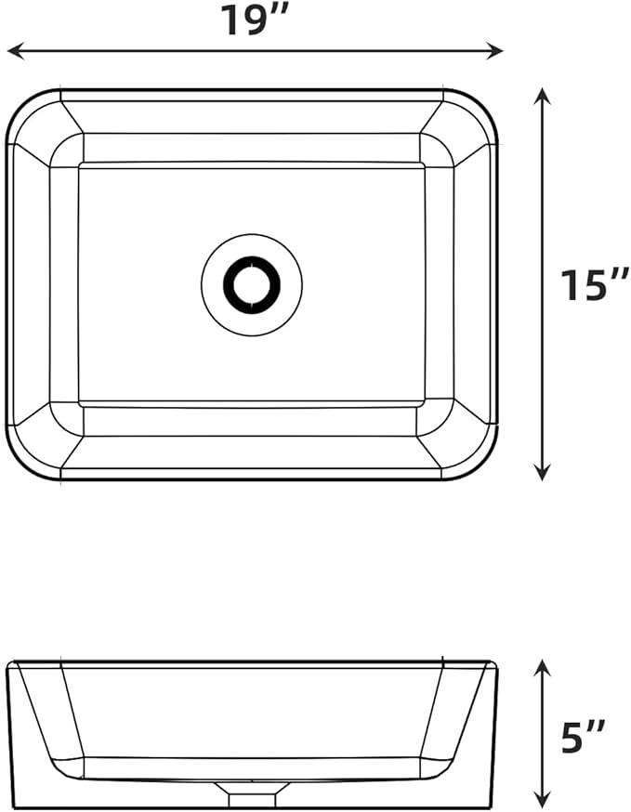

$40

GAOMON Vessel Sink Rectangular, 19"x15" Bathroom Sink White Ceramic Lavatory Vanity Above Counter Vessel Sink Art Basin - white